**LABSHEET 01 - Programming**

Shape

**Date: 05.02.2025**  **Submission Date:** on or before Thursday,07.02.2025

**Tasks**

1. 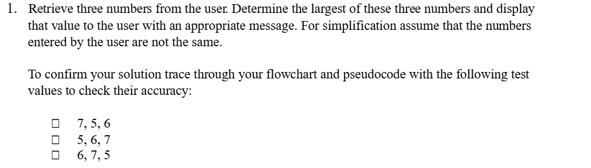
2. Write an algorithm to find the factorial of any number

Factorial ---> n! = nx(n-1)x(n-2)...1

1. Write an algorithm to find the given number is Prime or not
2. 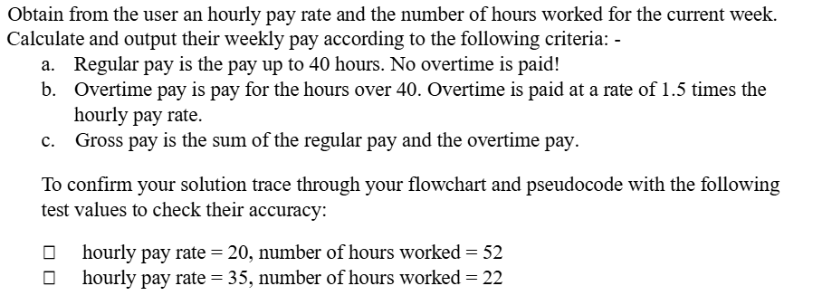
3. Design an algorithm in flowchart to find the smallest number in a group of three real numbers.
4. Design an algorithm in flowchart to solve the quadratic equation: ax2 + bx + c =0 with the inputs a, b, and c
5. Design an algorithm in flowchart to determine if a triangle is equilateral, isosceles, right-angled or isosceles right-angled triangle when a,b,c - the lengths of three sides of this triangle - are given
6. Design algorithm to check if a given year is leap year or not.(Leap year is divisible by 4 but not by 100 or divisible by 400.) Hint: leap year is the year divisible by 4 but not divisible by 100, or it is divisible by 400